# Lab: Asynchronous Programming

Problems for exercises and homework for the ["JavaScript Apps" course @ SoftUni.](https://softuni.bg/courses/js-applications)  
The following tasks do not have tests in the Judge system. They are for practice.

## Github Commits

Write a JS program that loads all commit messages and their authors from a github repository using a given HTML.

Skeleton will be provided in the **Resources** **folder**.

The loadCommits() function should get the username and repository from the HTML textboxes with IDs "username" and "repo" and make a GET request to the **Github API**:  
**https://api.github.com/repos/<username>/<repository>/commits**

Swap <username> and <repository> with the ones from the HTML:

* In case of **success**, for **each** entry add a list item (<li>) in the unordered list (<ul>) with id "commits" with text in the following format:

"<commit.author.name>: <commit.message>"

* In case of an **error**, add a single list item (<li>) with text in the following format:  
  "Error: <error.status> (<error.statusText>)"

### Screenshots:

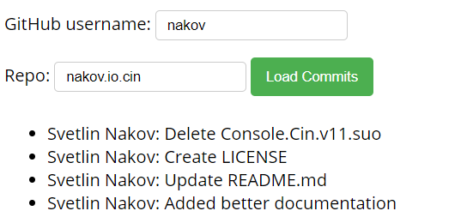

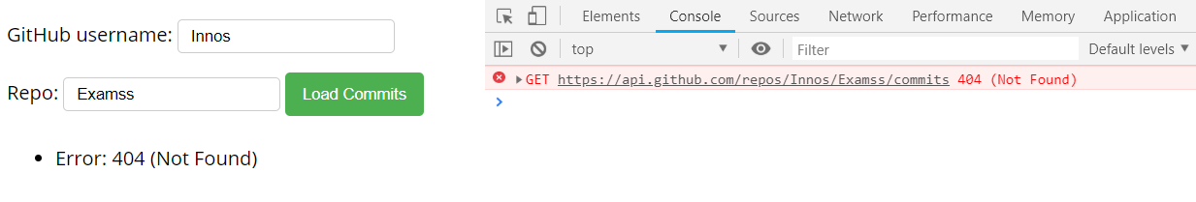

## Blog

Write a program for reading blog content. It needs to make **requests** to the **server** and display **all blog posts** and their **comments**.  
Firebase URL - [https://blog-apps-c12bf.firebaseio.com/](https://blog-apps-c12bf.firebaseio.com/$%7bendPoint%7d.json)

Skeleton will be provided in the **Resources** **folder**.

The button with ID "**btnLoadPosts**" should make a GET request to "**/posts**". The **response** from the **server** will be an **Object of objects.**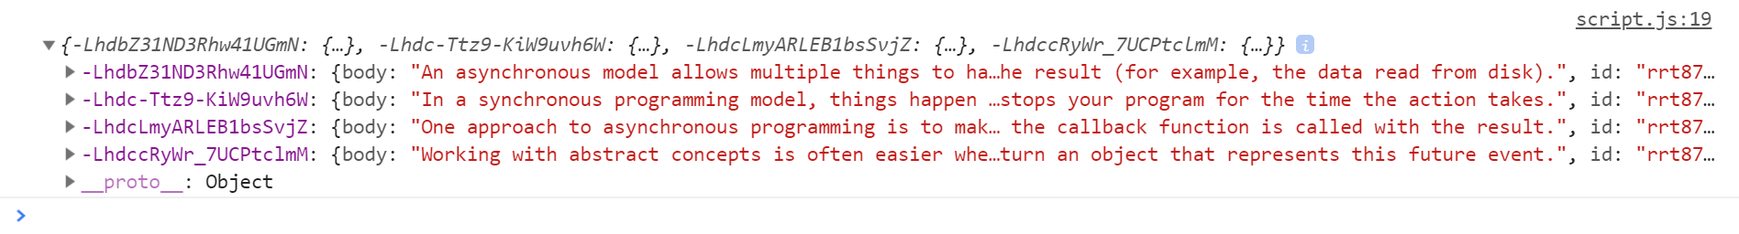

Each object will be in the following format:

{

body: {postBody},

id: {postId},

title: {postTitle}

}

Create an <option> for each post using its object key as value and current object title property as text inside the node with ID "**posts**".

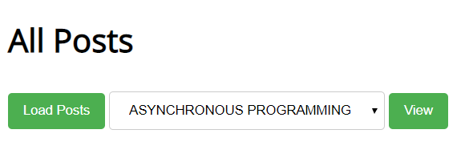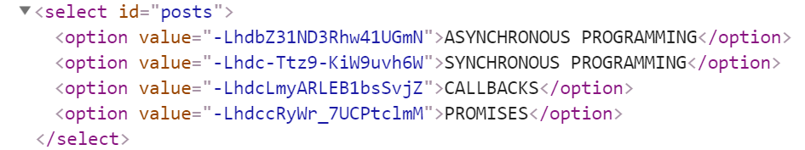

When the button with ID "**btnViewPost**" is clicked, a GET request should be made to:

* "**/posts/{postId}**" to obtain the selected post (from the dropdown menu with ID "**posts**") - The following **request** will return **a single object** as described above.
* "**/comments -** to obtain all comments. The request will **return** a **Object** of **objects**.  
  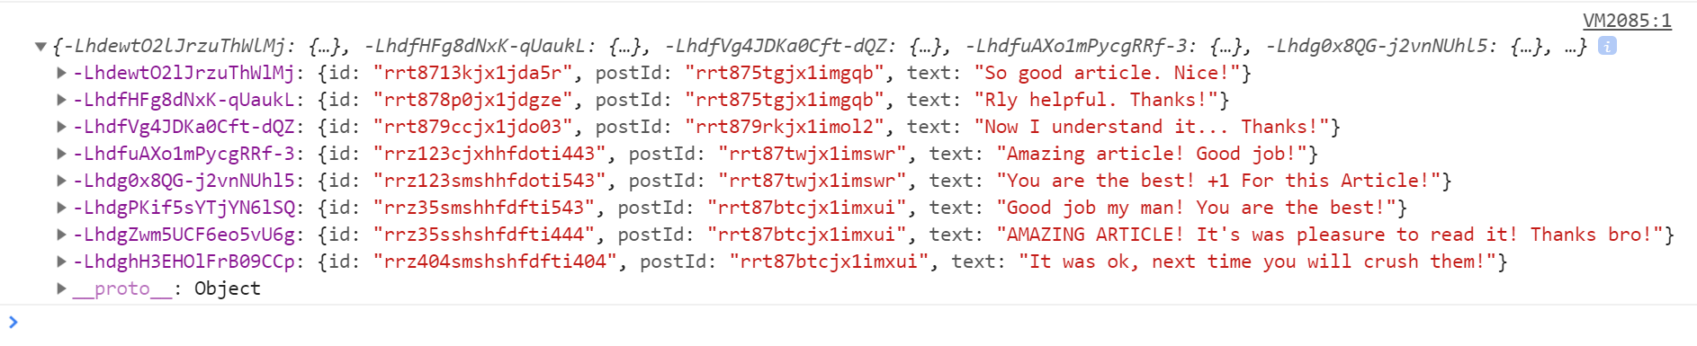

Each object will be in the following format:

{

id: {commentId},

postId: {postId},

text: {commentText}

}  
You have to find this comments that are for the current post (check the postId property)

Display the post title inside **h1** with ID "**post-title**" and the post content inside **ul** with ID "**post-body**". Display **each comment** as a **<li>** inside **ul** with ID "**post-comments**". Do not forget to clear its content beforehand.

